Ansible Task 01
- Watch ansible-01 video and write down notes.
- Setup one master and two worker nodes in ansible.
  - Launch 3- ec2 instances
I have launched < ubuntu-server-image >
Instance_type = t3.micro
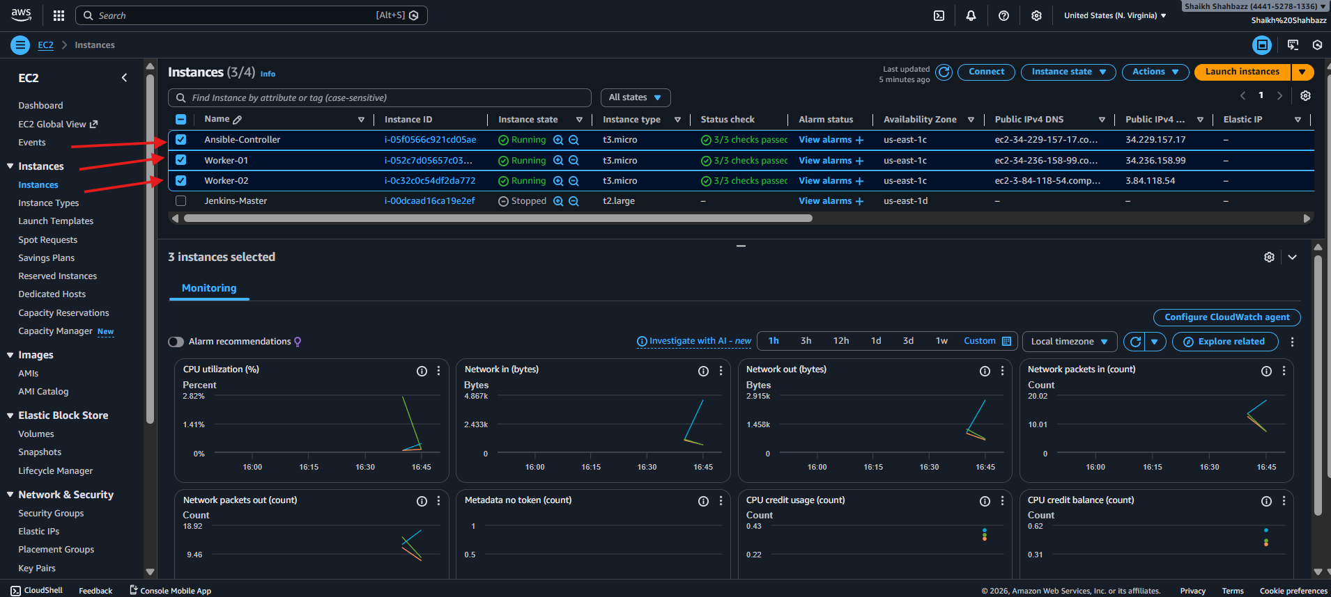
- Ansible-Controller
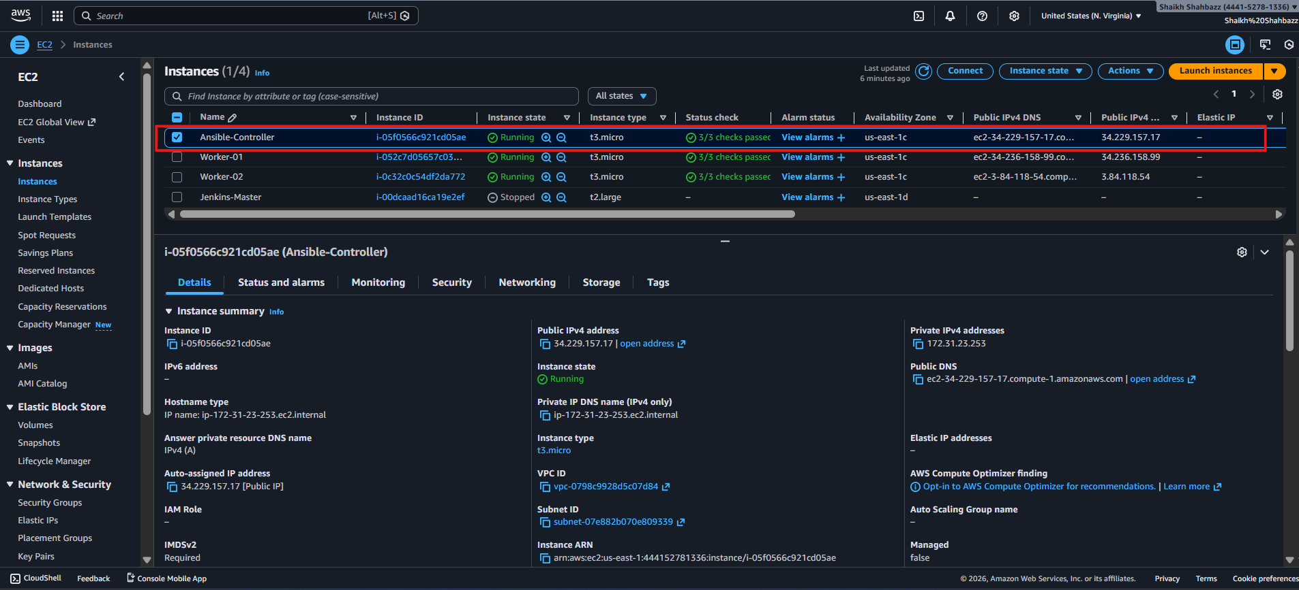
- Worker-01
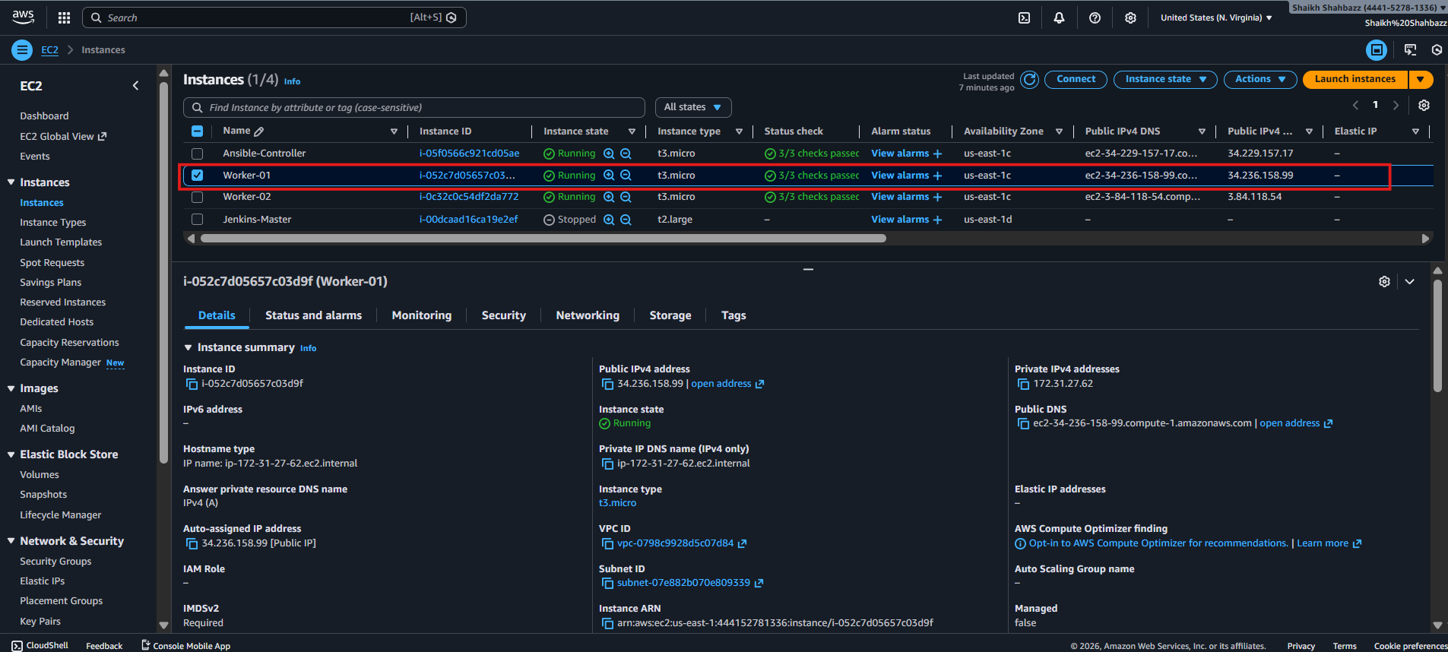
- Worker-02
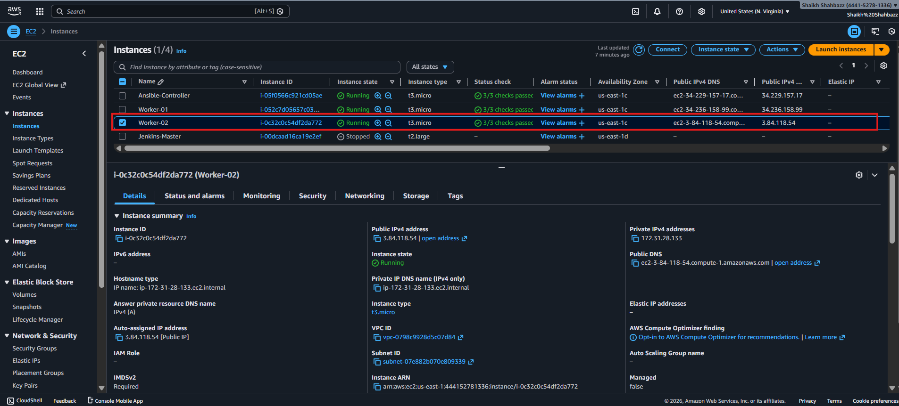
  - Now connect to Ansible-Controller via ssh and switch to root user
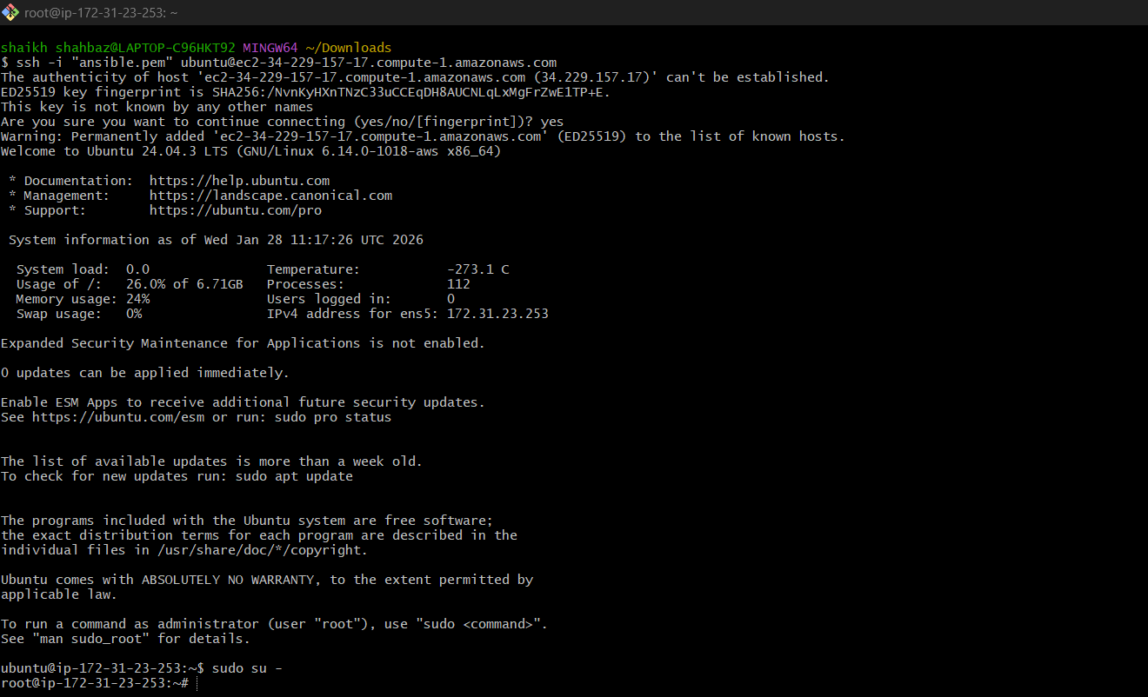
  - For Ansible to run Python is the Prerequisite because ansible is built using python
language
  - Check python version
python3 --version

Prerequisites
Nodes
  - Master (control node): where Ansible is installed
  - Workers: 2 managed nodes
On all nodes
  - Python installed
  - SSH enabled
  - Same user (or sudo access)

Install Ansible on Master
Ubuntu
sudo apt update
sudo apt install -y ansible
Verify:
ansible --version
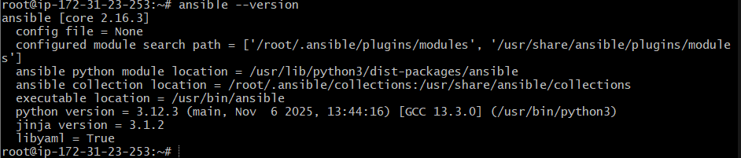

By default, Ubuntu does not create /etc/ansible/ansible.cfg or /etc/ansible/hosts anymore — instead, you’re expected to create your own config and inventory in your project directory.
sudo mkdir -p /etc/ansible
sudo vi /etc/ansible/ansible.cfg

Created global inventory
sudo vi /etc/ansible/hosts
[all] ------ Group name
172.31.27.62 ------- < private-ip-of-worker-01 >
172.31.28.133 ------- < private-ip-ofoworker-02 >

[worker01] ------- Group name
172.31.27.62 ------- < private-ip-of-worker-01 >

[worker02] ------- Group name
172.31.28.133 ------- < private-ip-ofoworker-02 >


—> to have connectivity we need to create a ssh-keygen in ansible master server
means Ansible is trying to connect with the ubuntu user, but the SSH key is missing or not set up properly between your master and worker nodes.
Fix SSH Access Between Master and Workers
Configure SSH Key-Based Access
On master:
ssh-keygen
Do ssh-kegen from Master server
—> now after creating key copy the pub key
cat /root/.ssh/id_ed25519.pub
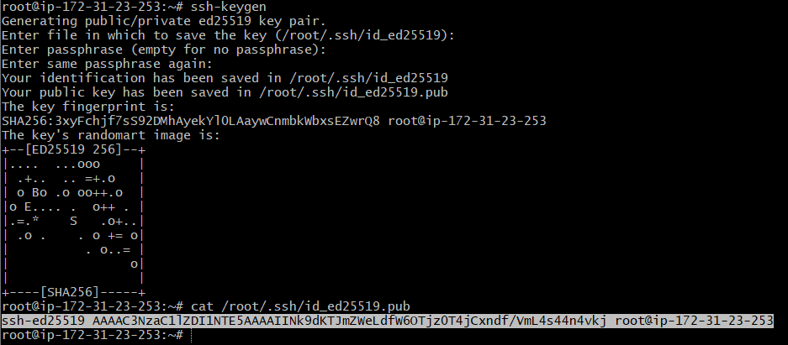
—> copy the key and paste in other two instances
—>.ssh/ authorized_keys
—> open worker1 server
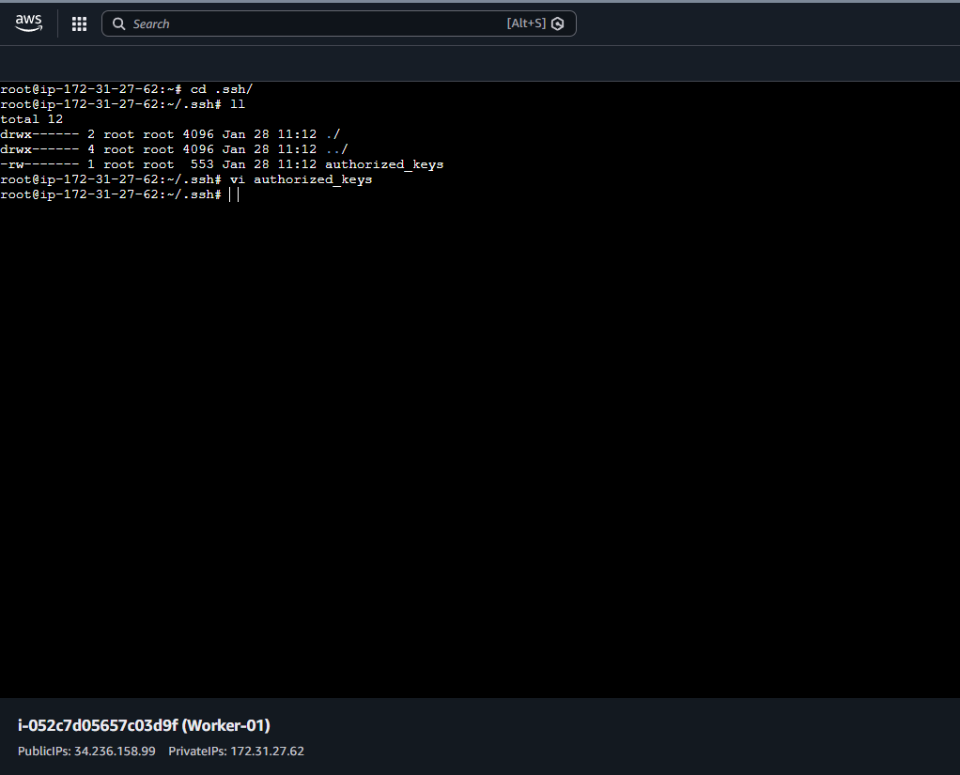
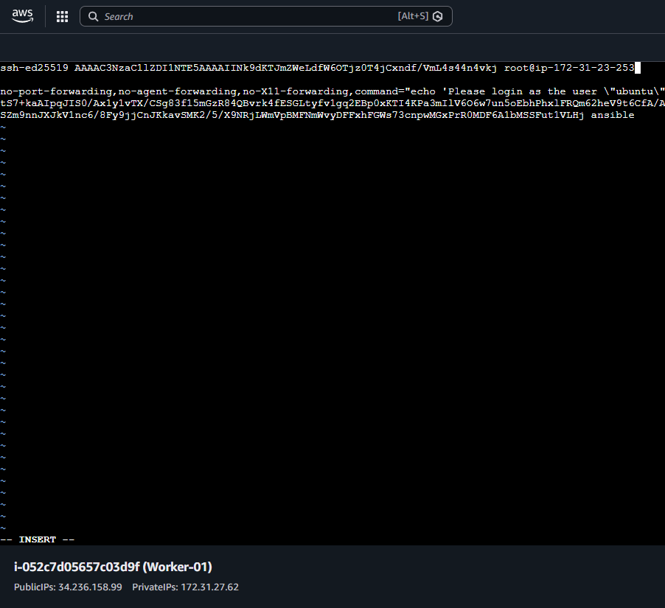

Similarly open worker2 server and add same key in authorizd_keys
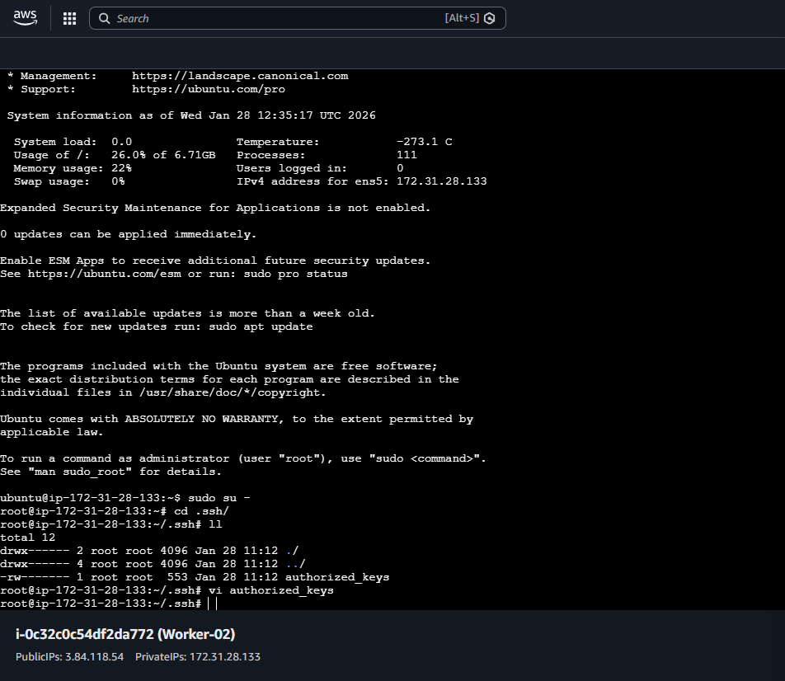

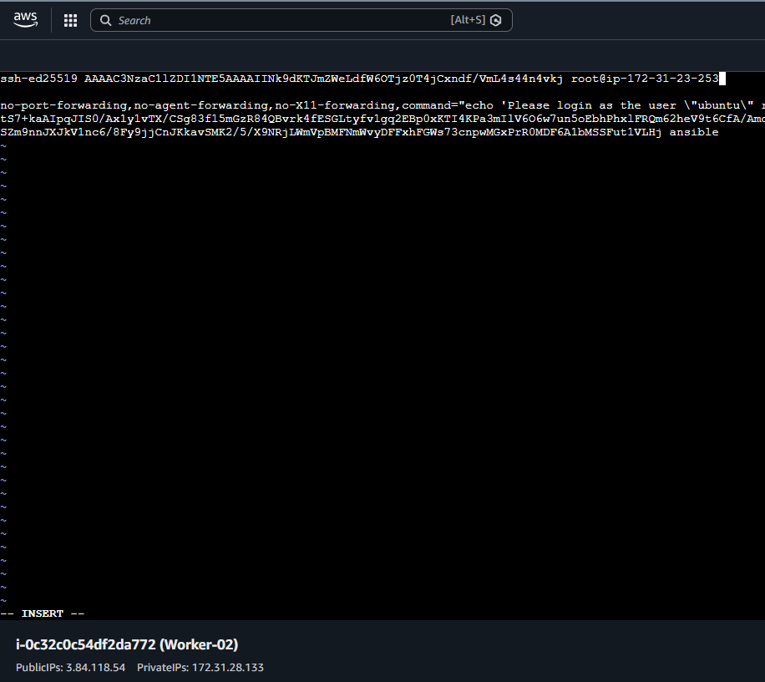

Test Connectivity for both the Workers
<worker01>
ansible all -m ping
Expected:
SUCCESS => ping: pong

<worker02>
ansible all -m ping
Expected:
SUCCESS => ping: pong


- Execute the adhoc command shared in #dvps-cloud-documents-16 Channel.
# To check the connetivity between slaves
    - ansible all -m ping


Because we have given group names worker1, worker2
# How to gather facts of slave machine
    - ansible all -m setup

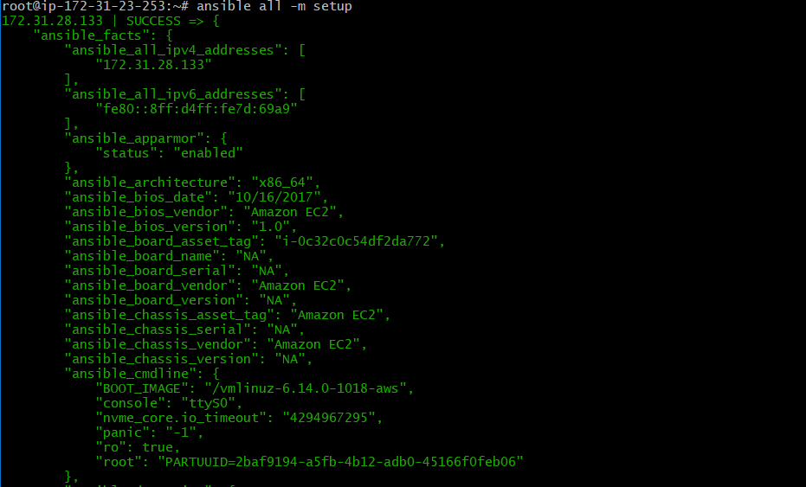

# TO checkthe uptime of a slave machine
    - ansible all -a uptime


# to check with all log details
    - ansible all -m ping -vvvv
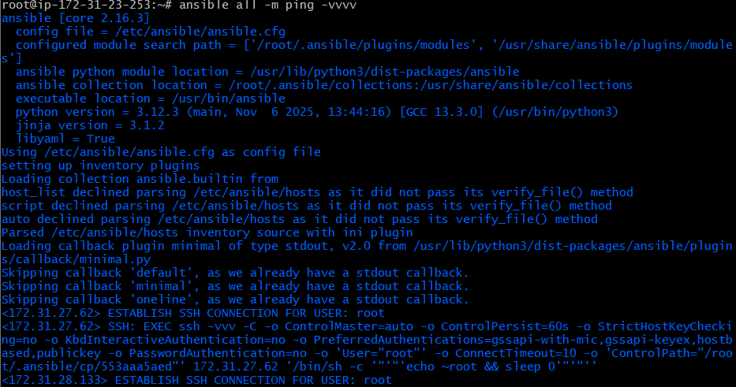

# check the free memory or memory usage of host
    - ansible all -a "free -m"
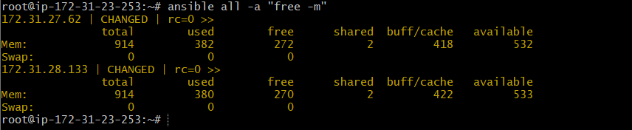

#Create directory using shell module
    - ansible all -m shell -a “mkdir ansible.log”


—> what it does it will create ansible.log directory in all workers server



# Install a package using yum command ansible all -m yum -a "name=httpd state=installed"
—> iam using ubuntu
Command
ansible all -m apt -a "update_cache=yes cache_valid_time=0" -b
Use
• Updates package list on all Ubuntu nodes
• -b → run as root (sudo)
Command
ansible all -m apt -a "name=apache2 state=present" -b
Use
• Installs Apache web server on all nodes
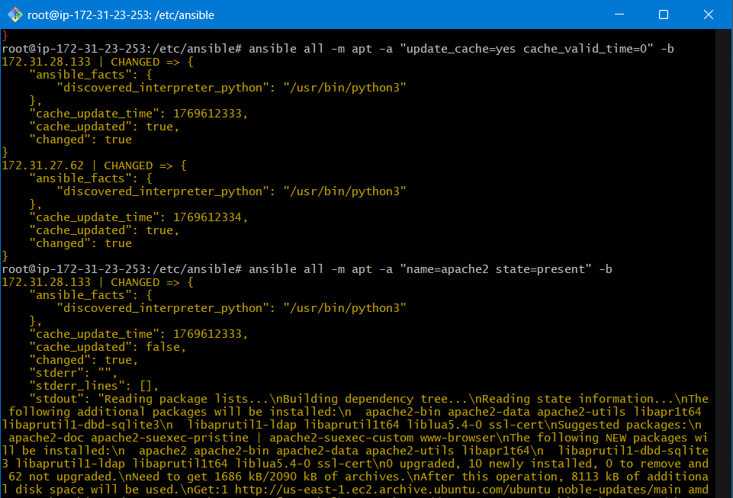
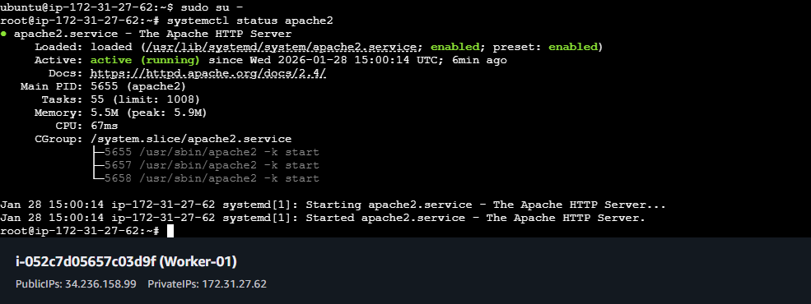

Worker-machine-01 : http://34.236.158.99/
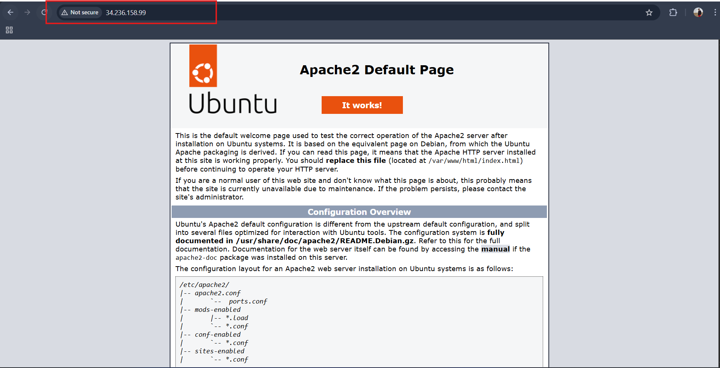

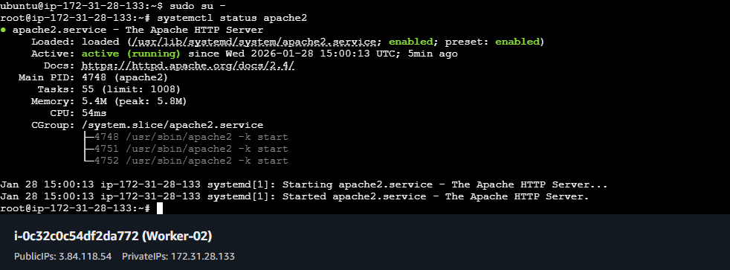

Worker-machine-02: http://3.84.118.54/
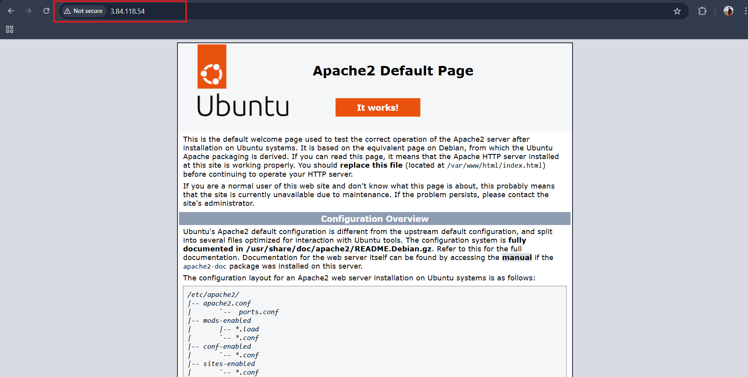

# Start or stop the service
# To Start
    - ansible all -m service -a "name=httpd state=started enabled=yes"
# To stop
    - ansible all -m service -a "name=apache2 state=stopped enabled=yes"
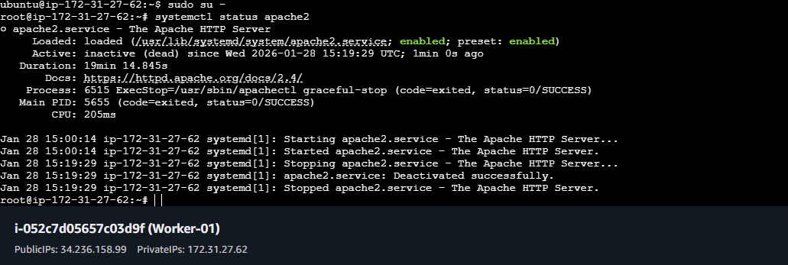

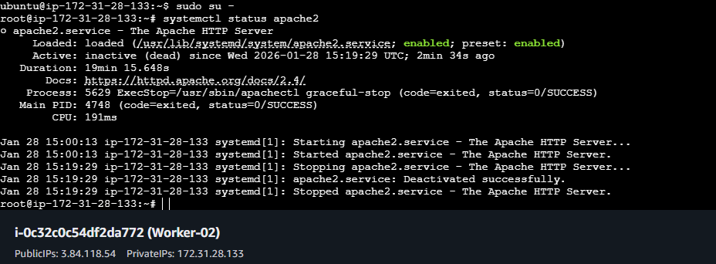

#Create the user on ALL servers
    - ansible all -m user -a "name=weblogic state=present"
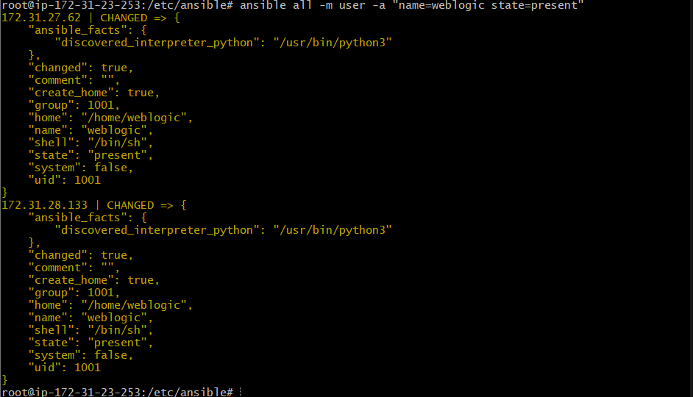

#Verify user exists
    - ansible all -m shell -a "id weblogic"



# Create a file with 755 permission
    - ansible all -m file -a "path=/root/testfile state=touch mode=0755"
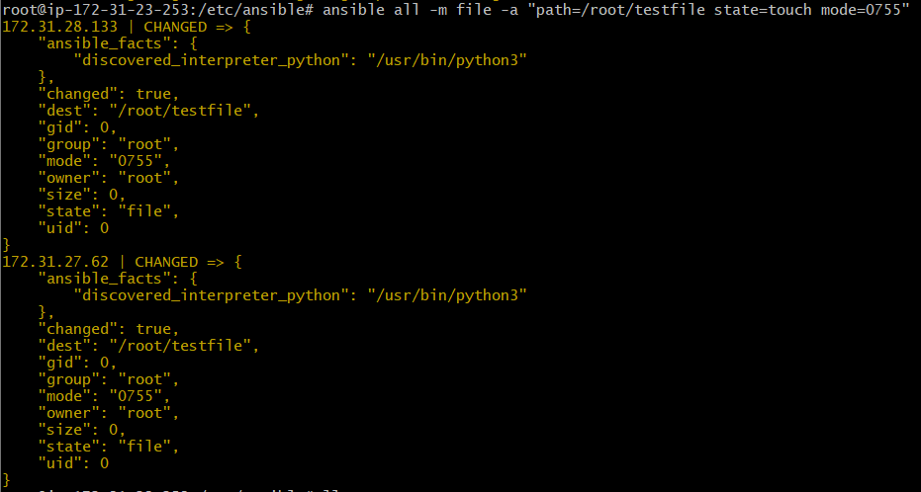

# Create a Linux user group
    - ansible all -m group -a "name=test state=present" -b -K

BECOME password: ansible123
